**Group Members:**

* **Deshpande,Aditya**
* **Meka,Tej Kiran**
* **Jagadish Rao**
* **Mahesh Vemula**

**Task1: Android application using TI sensor tag.**

Step 1: Extract the application from download file.

Step 2: Run the application on the device after enbling debugging mode.

Step 3: Observe the output and take the screen shots of result.

First screen of the applciation

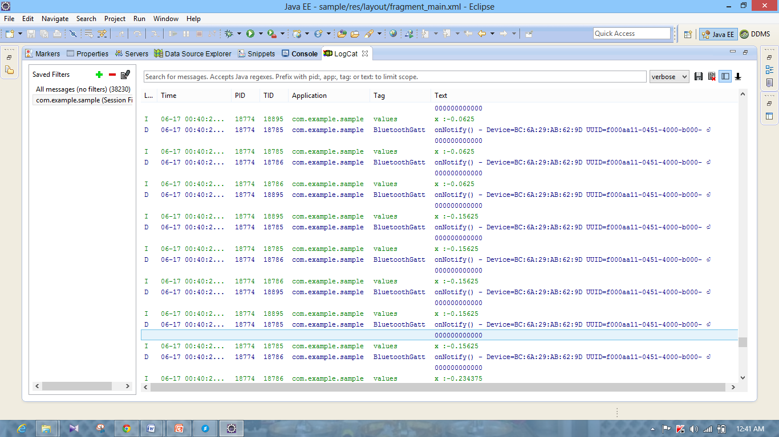

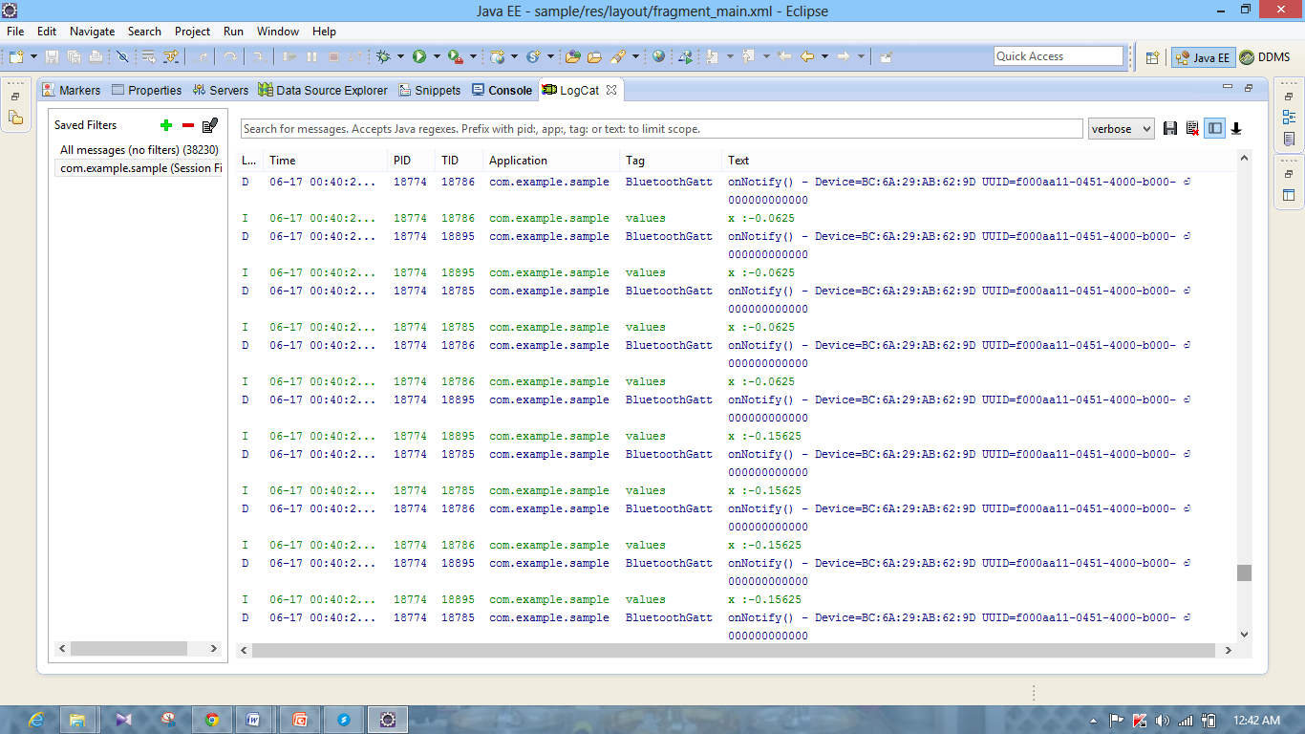

**Task 2: Mobile sensor with Android sensor app**

Step 1: Extract and modify the application from blackboard.

Step 2: Run the application on the device after enbling debugging mode.

Step 3: Observe the output and take the screen shots of result.



Initial screen of the application

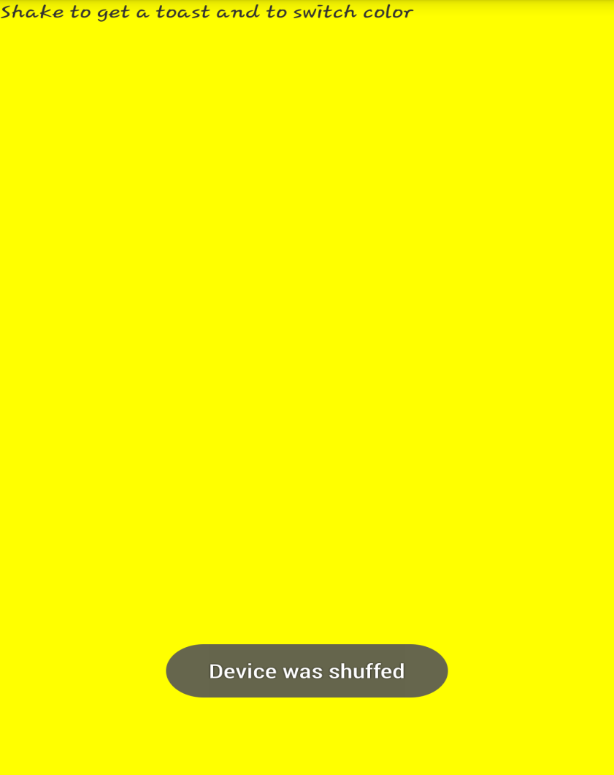

When we shuffle the device the sensor detects and gives sensor output. By detecting output we change the color of the device.

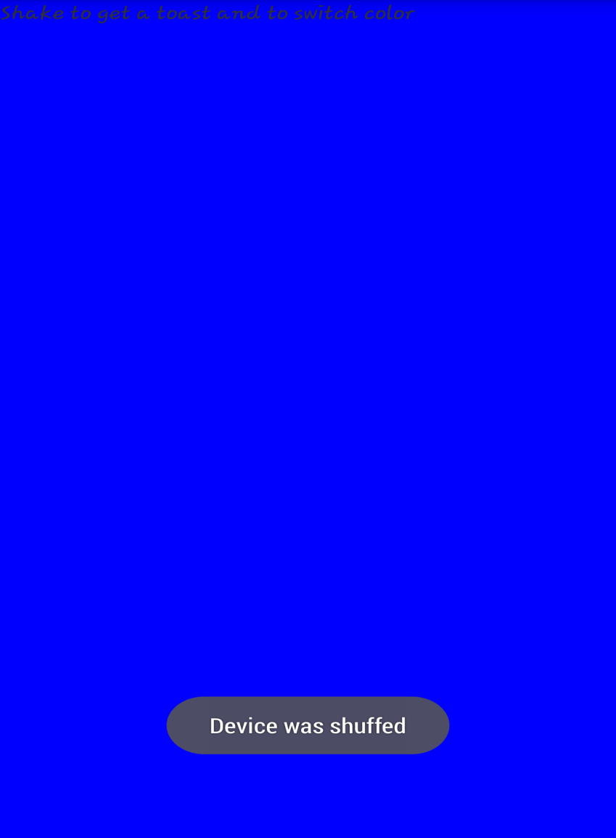

Again when we shuffle the device the sensor detects and gives sensor output. By detecting output we change the color of the device.

**Task3: Geosensing android application**

Step 1: Exatract and modify the application and add libraries.

Step 2: Run the application on the device after enbling debugging mode.

Step 3: Observe the output and take the screen shots of result.

First screen detecting the geo loacation and Displaying Latitudes and Longitudes using google API service call with geo location coordinates.

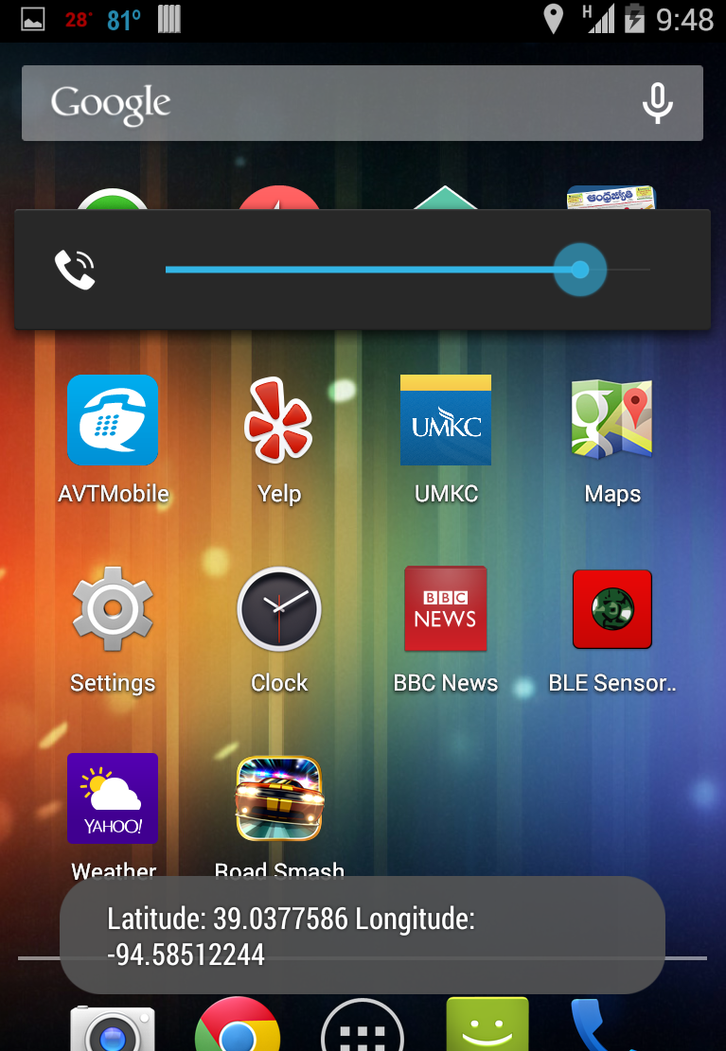

**Task4: Wiigee app with Android smartphone**

Step 1: Extract and modify the application. Modify build path.

Step 2: Run the application on the device after enabling debugging mode.

Step 3: Observe the output and take the screen shots of result.

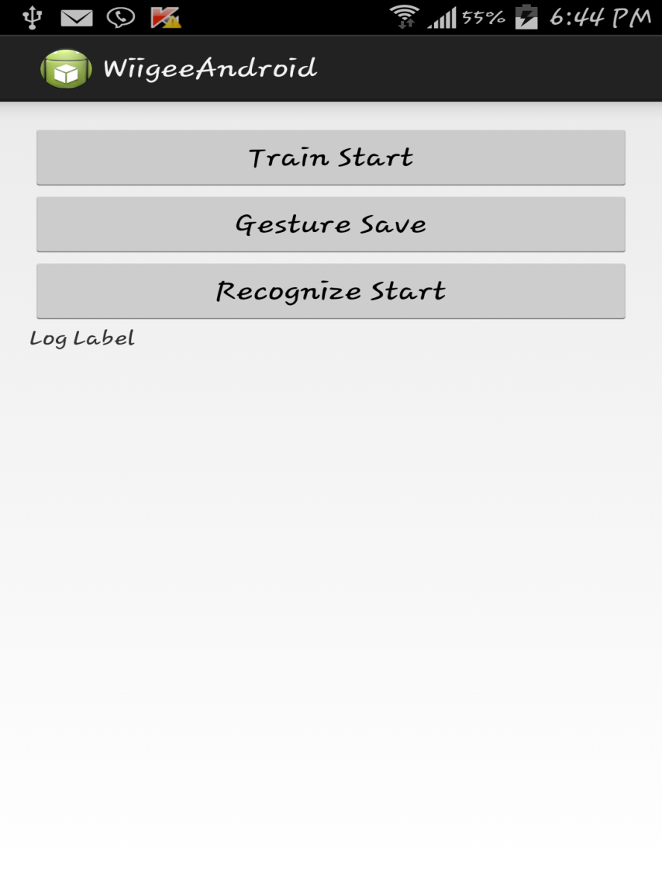

First screen of the application

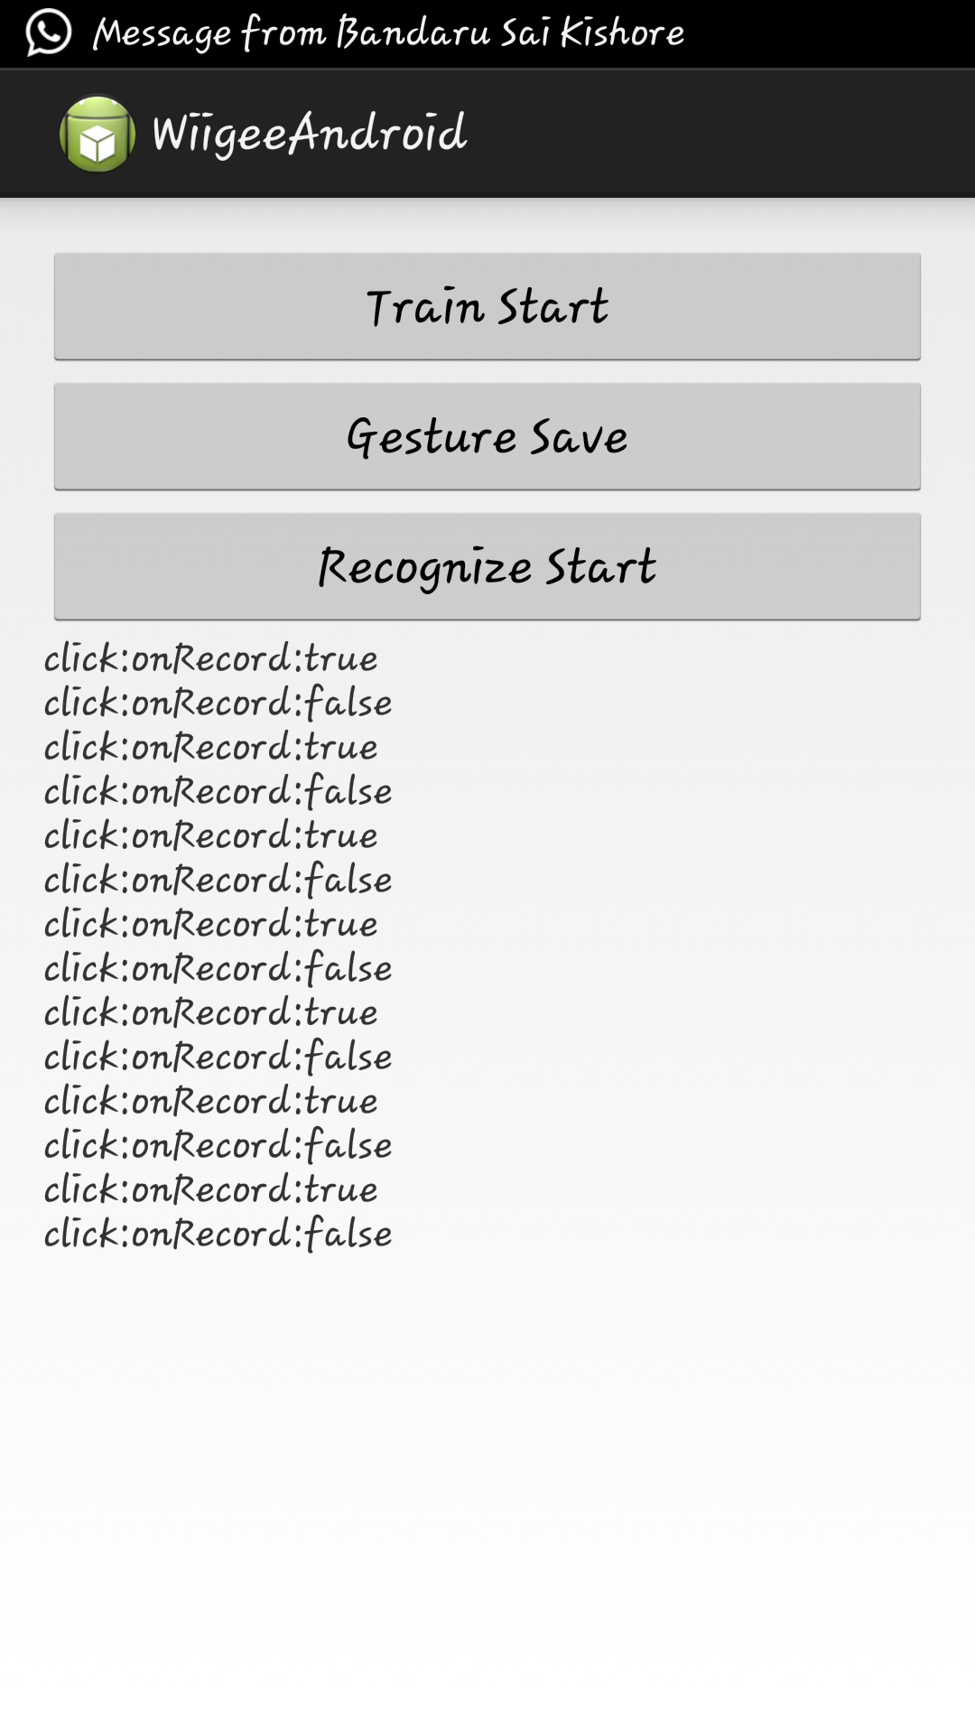

When we capture gesture click on record a gesture and after motion click on stop. After few samples click on save gesture.

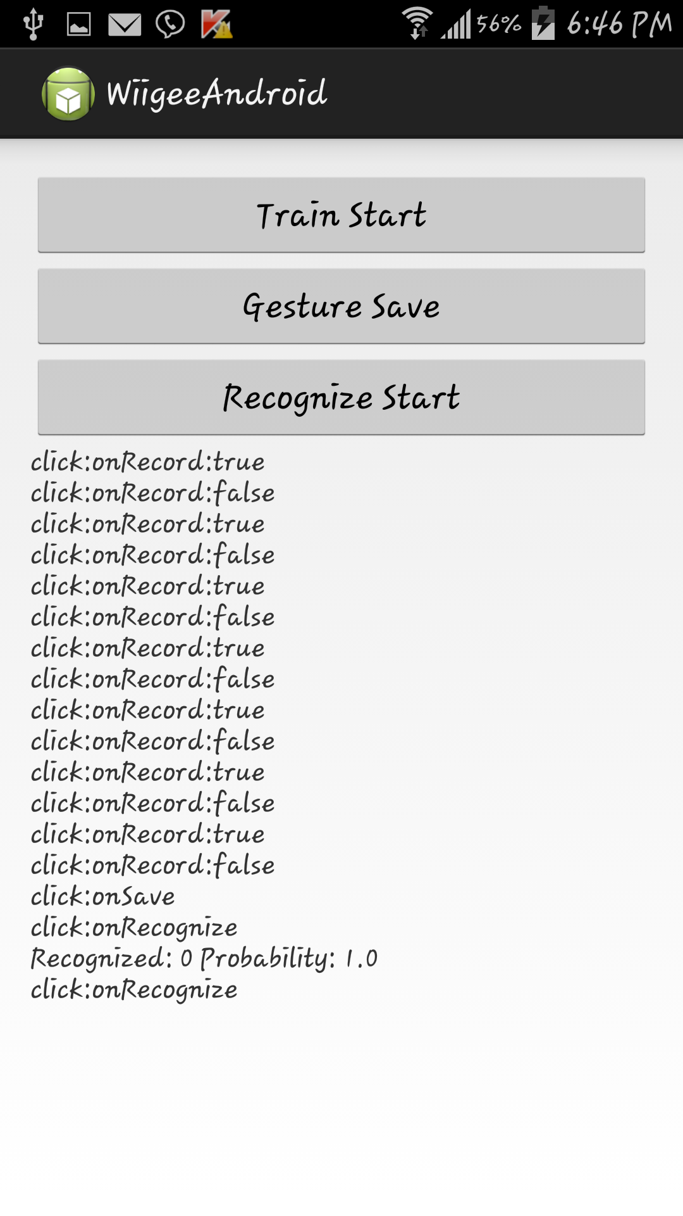

Now to check the gesture we click on recognize and make motion. If motion matches it shows probability of gesture match.

**Task5: Application using chronus watch**

Step 1: Install the chronus watch drivers.

Step 2: Enable ACC mode on watch.

Step 3: Click start capture on the application.

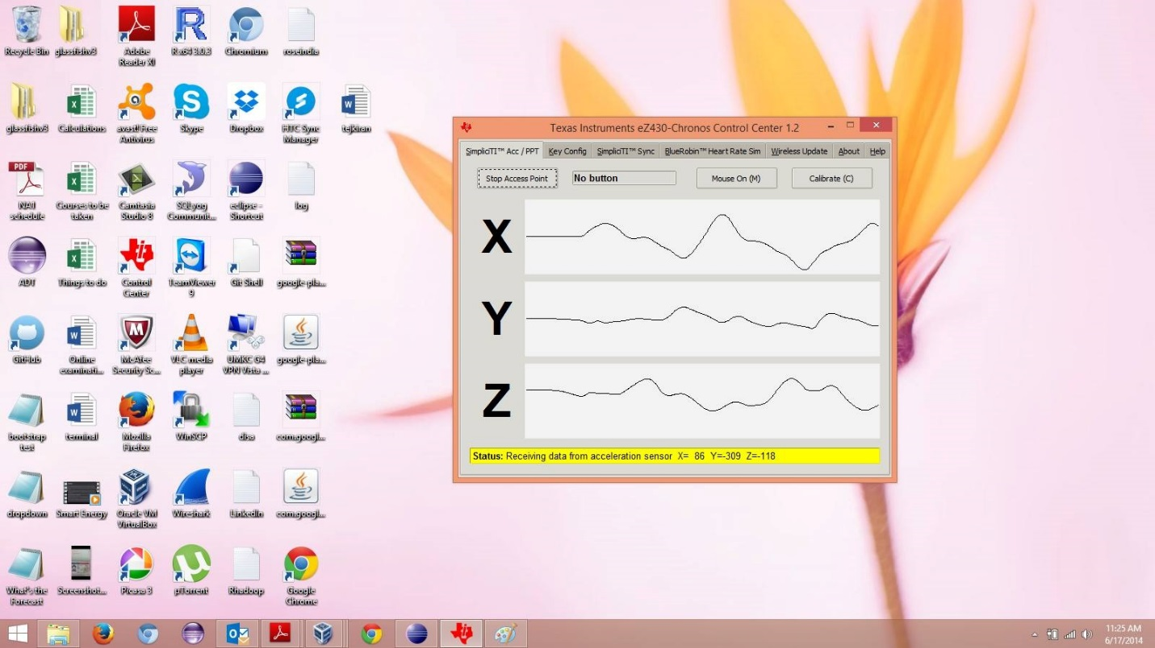

**Cloudera:**

* Below screenshot represents the login of cloudera manager

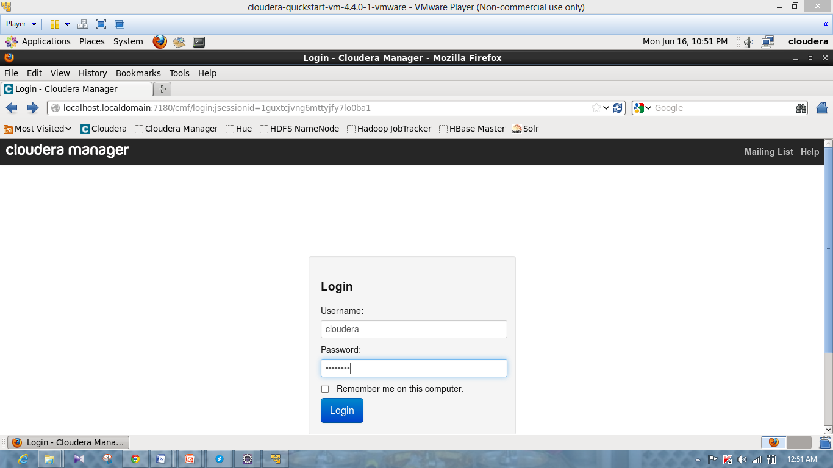

* Below screenshot represents the services list of cloudera.

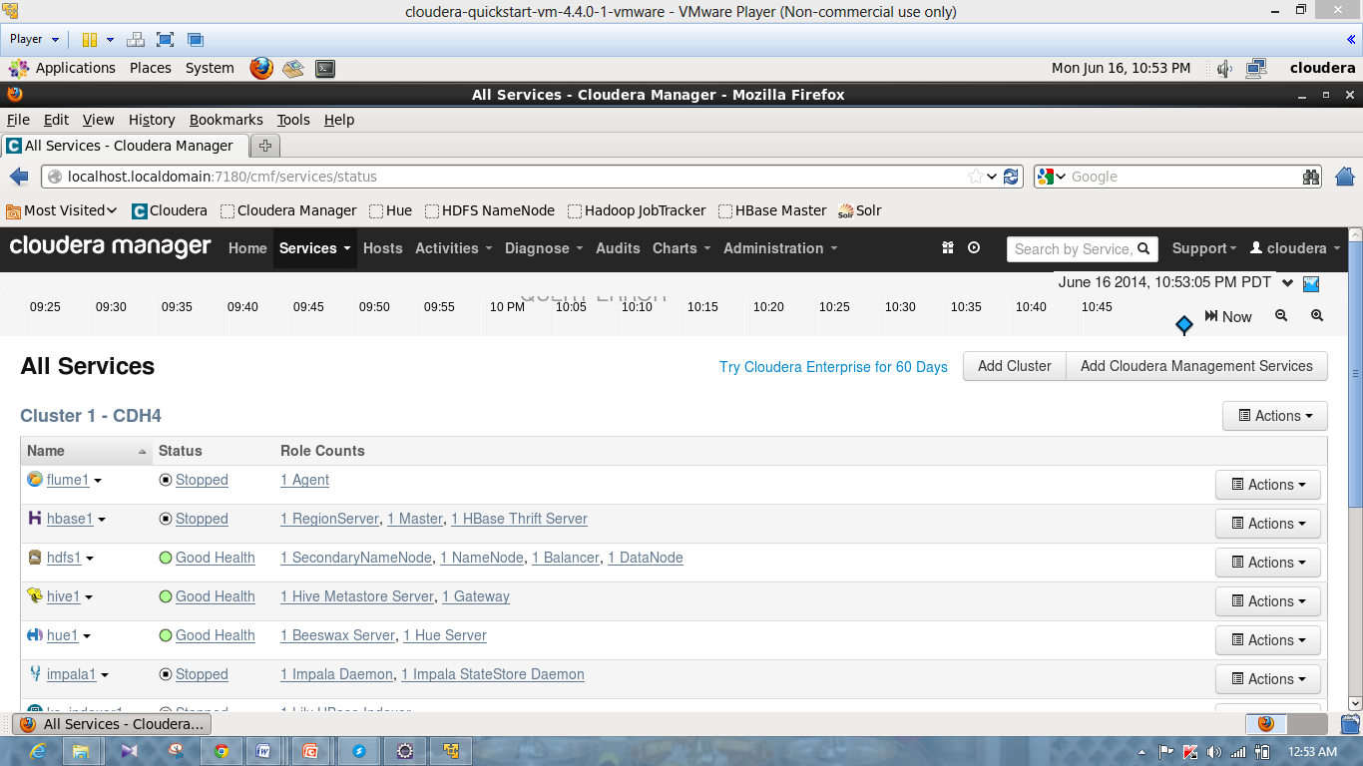

* Below screenshots represents the running of the map reduce application “Word Count”

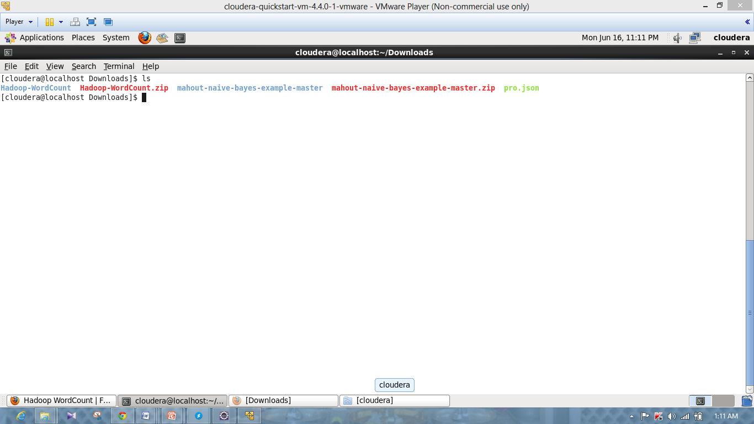

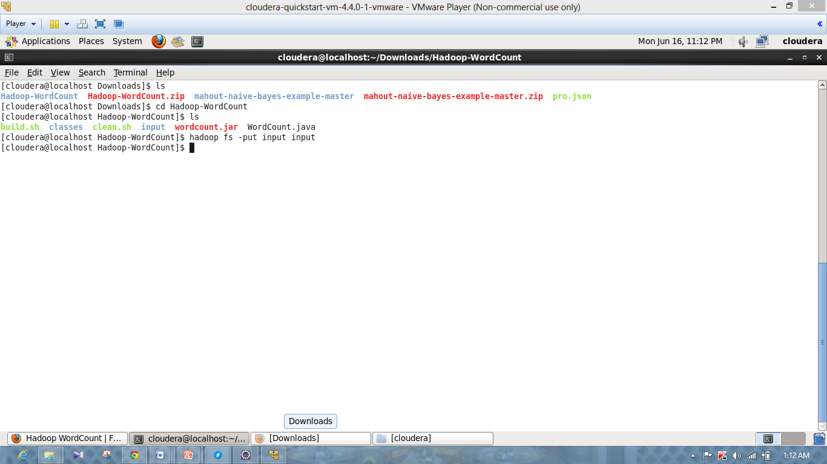

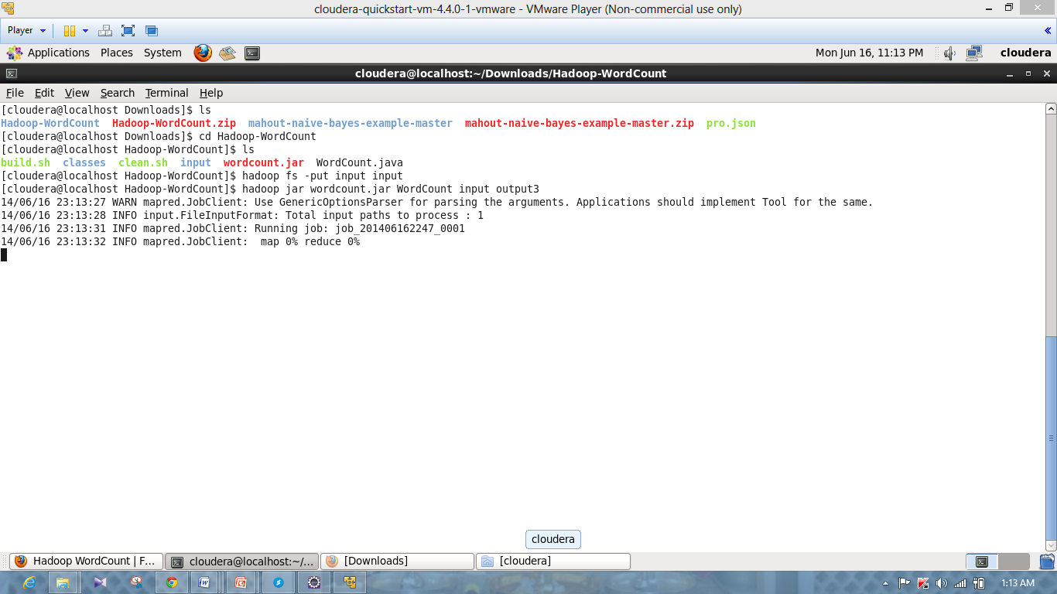

* Below Screenshot represents the output of the word count.

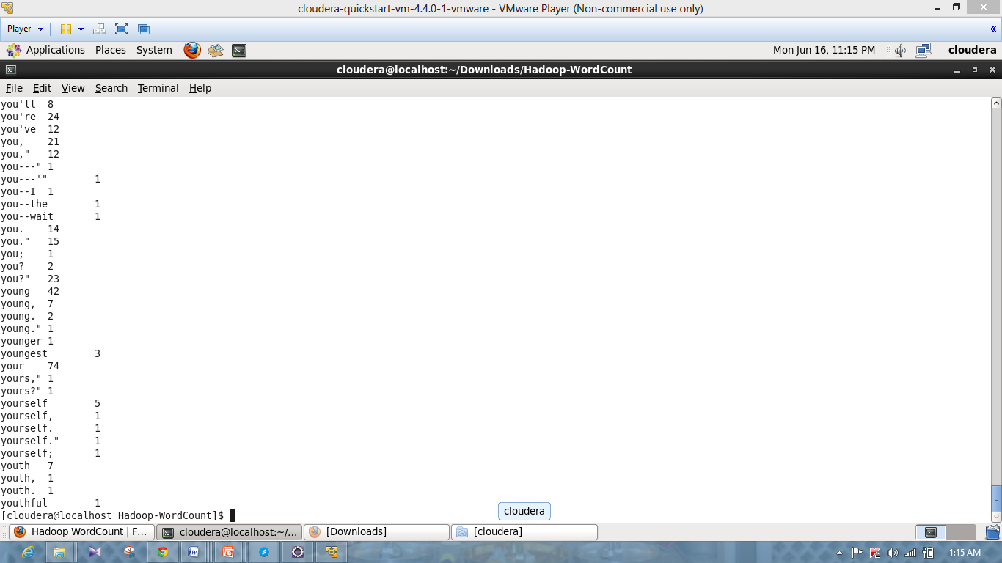

**Scrumdo:**

* Below screenshot represents the login page of the Scrumdo

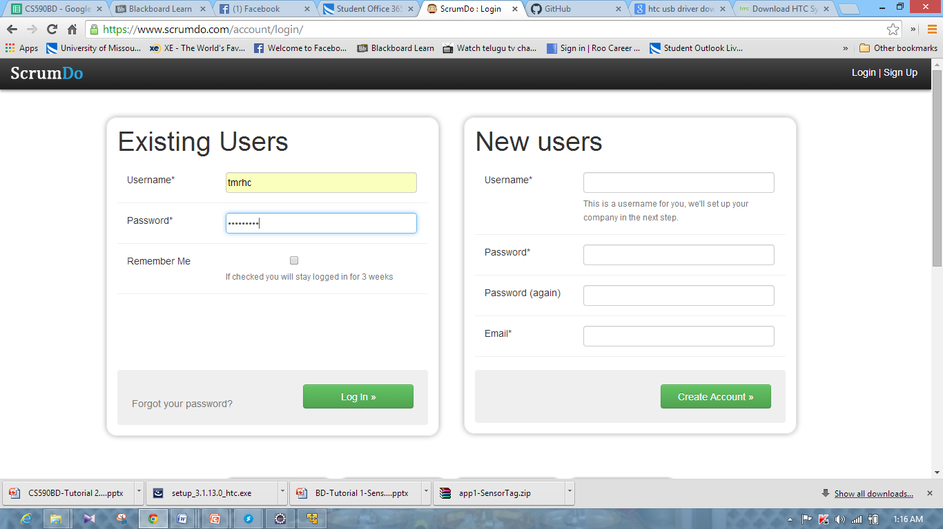

* Below screenshot represents the organization creation page.

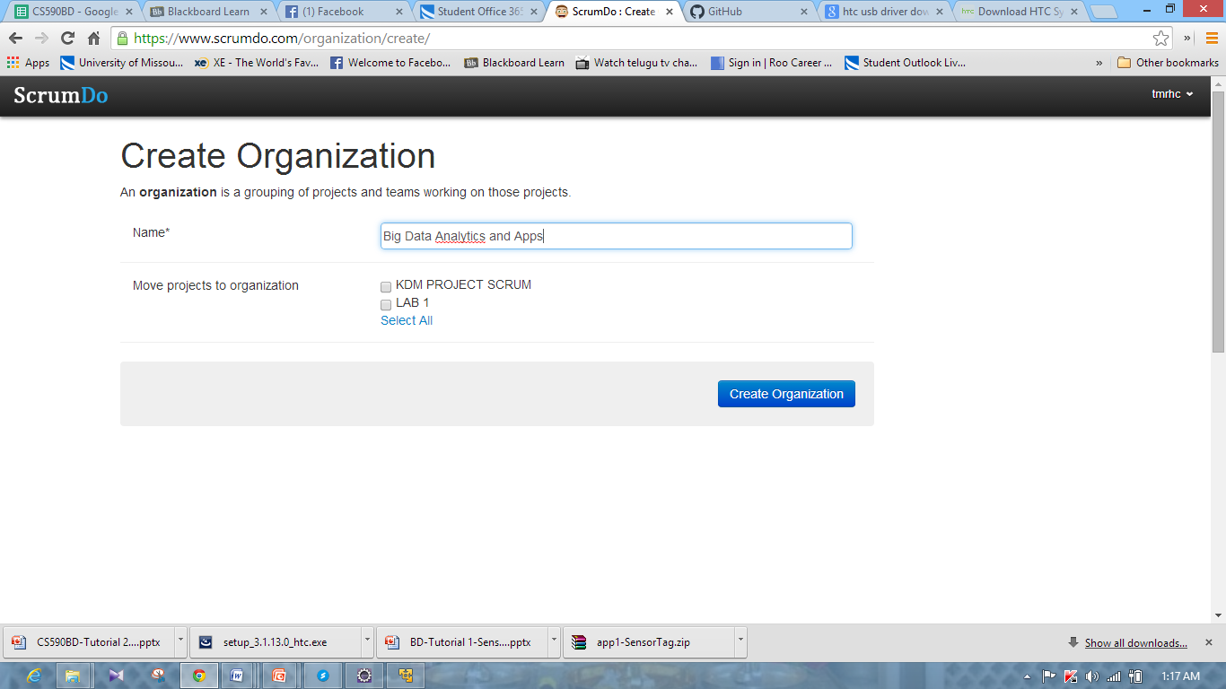

* Below screenshot represents the project creation page of the scrumdo.

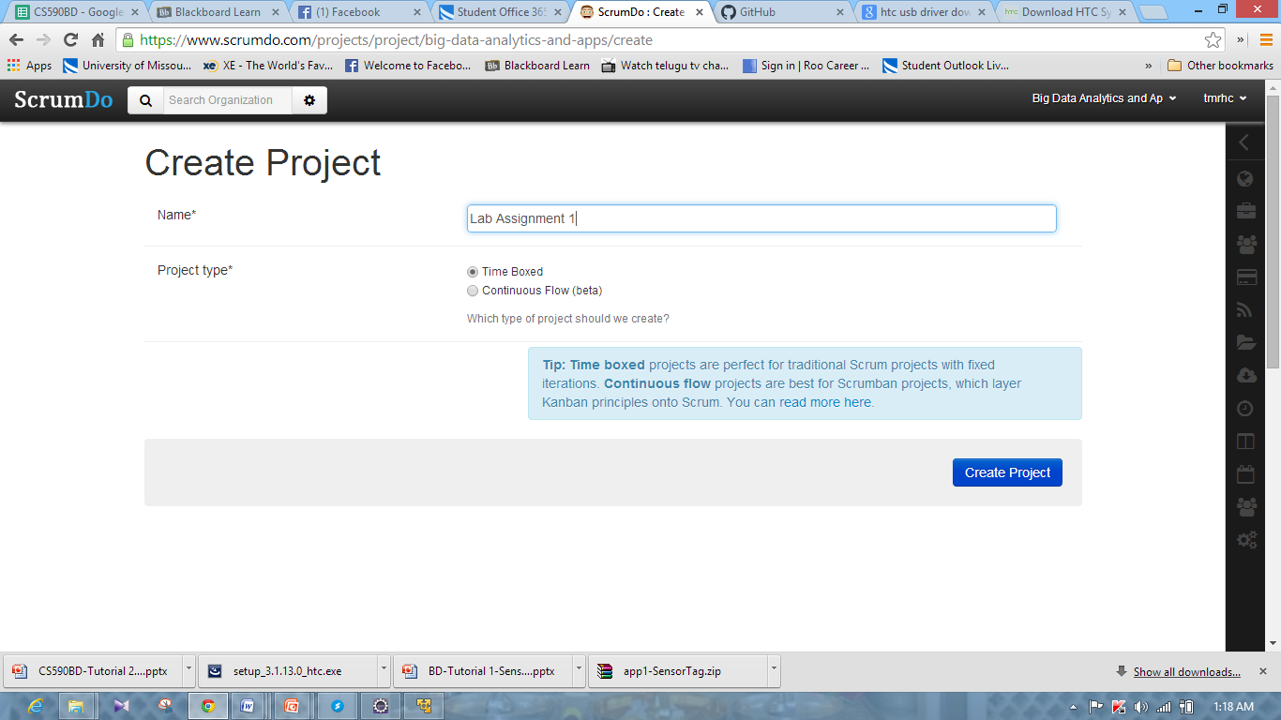

* Below screenshot represents the addition of Stories in Scrumdo.

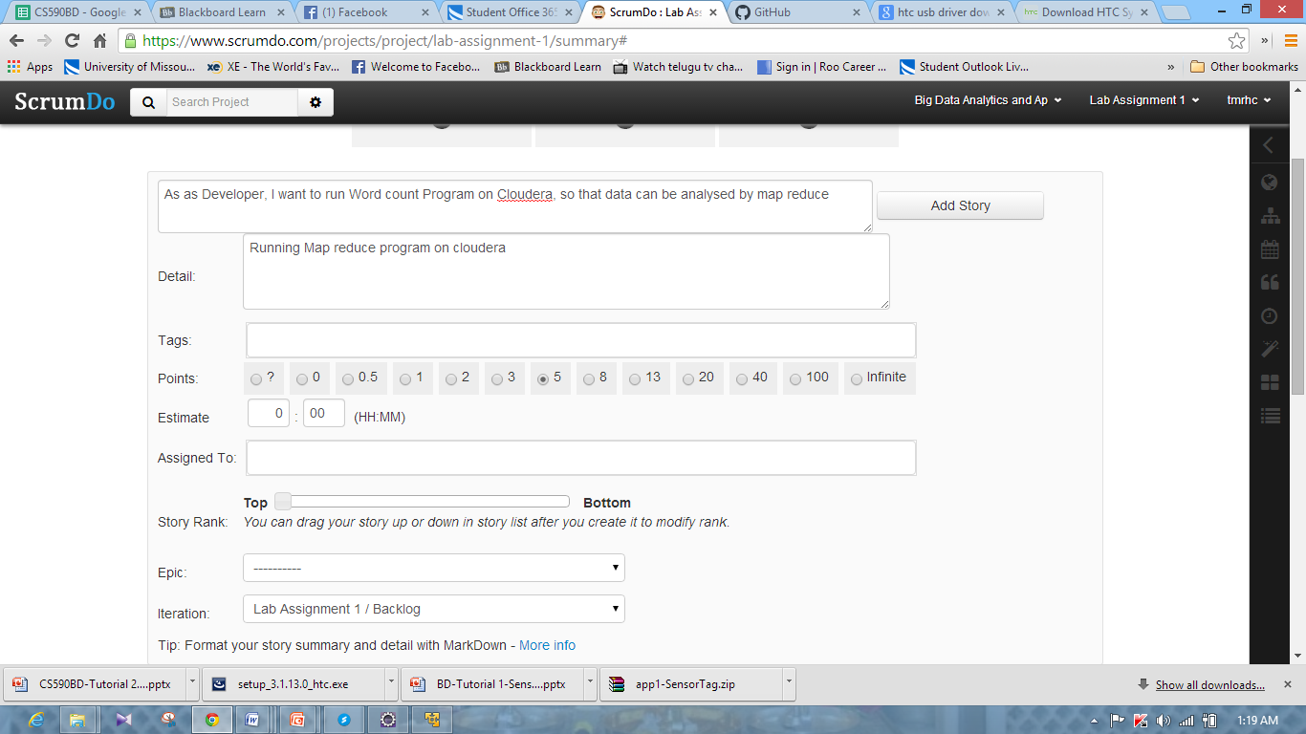

* Below screenshot represents the Backlog scrum board of Scrumdo.

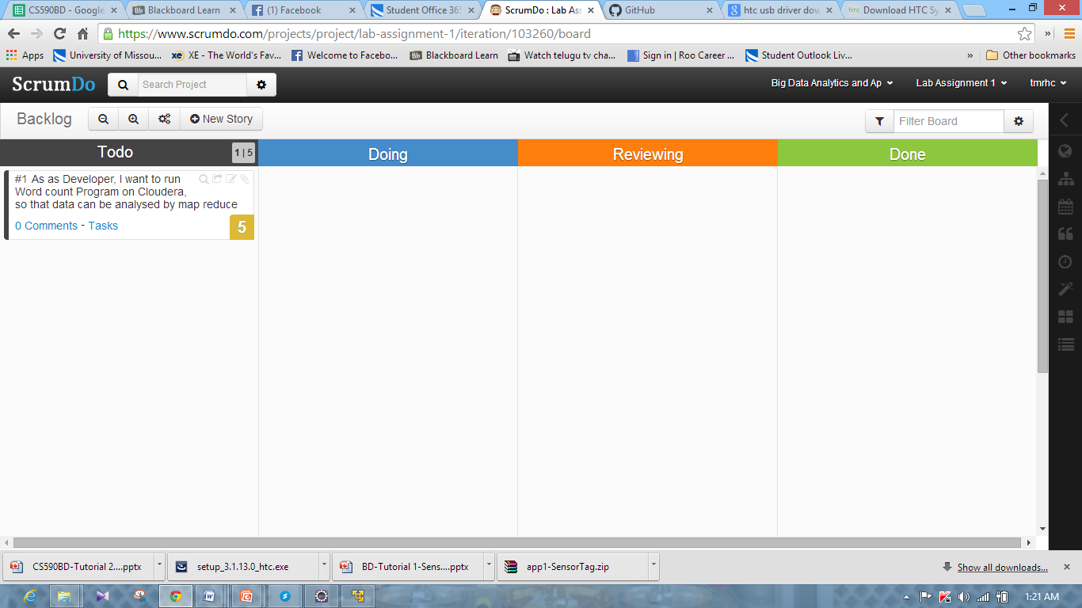

* Below screenshots represents moving of Story from different levels in Scrumdo.

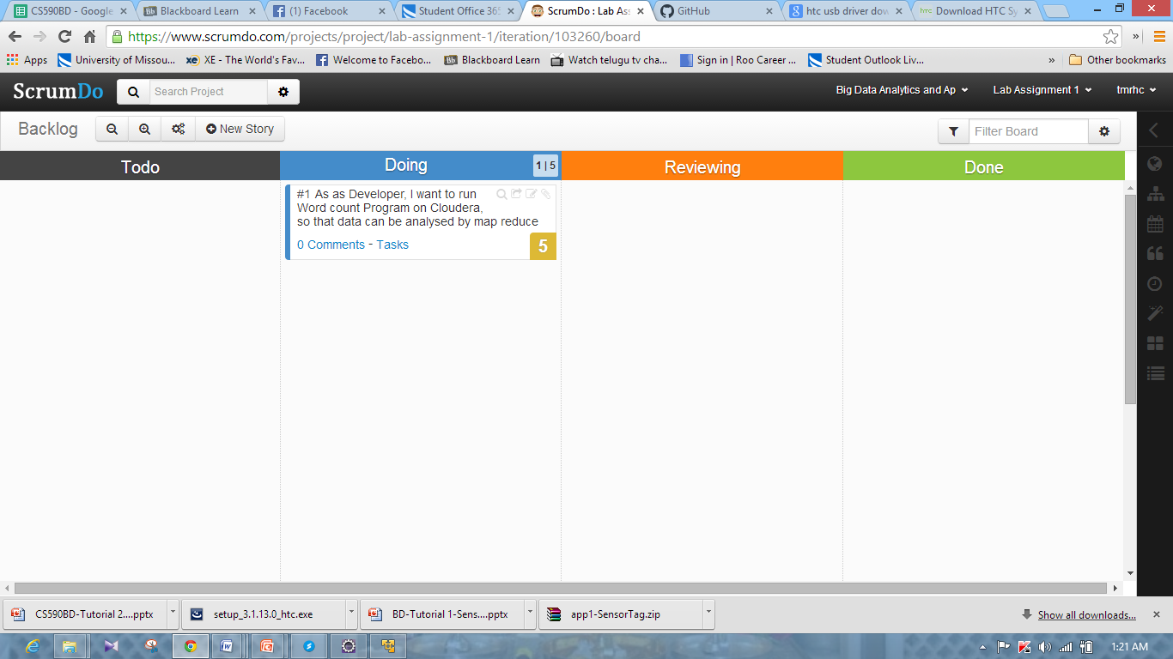

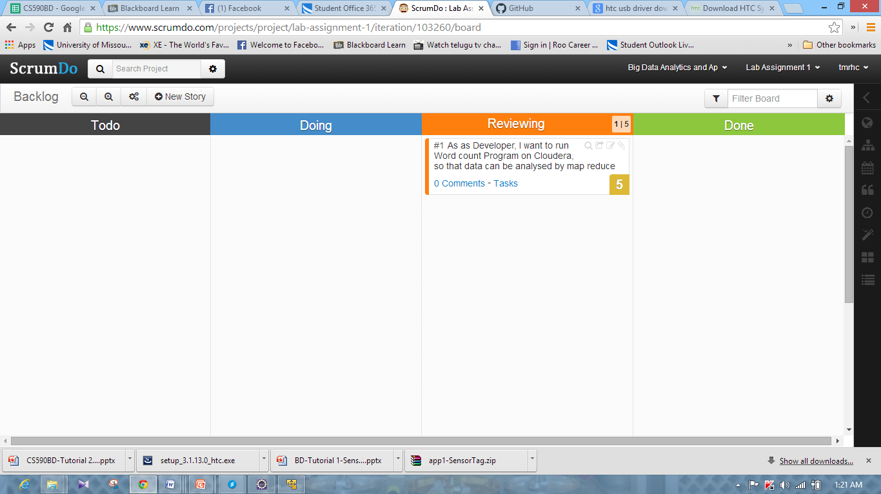

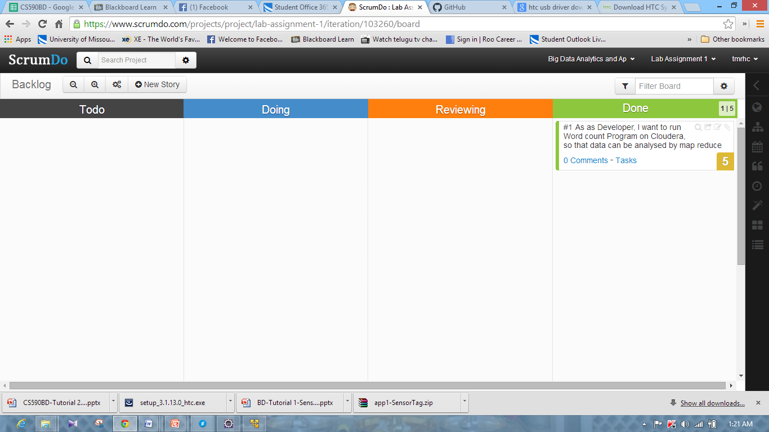

**Github:**

* Below screenshot represents the login page of Github.

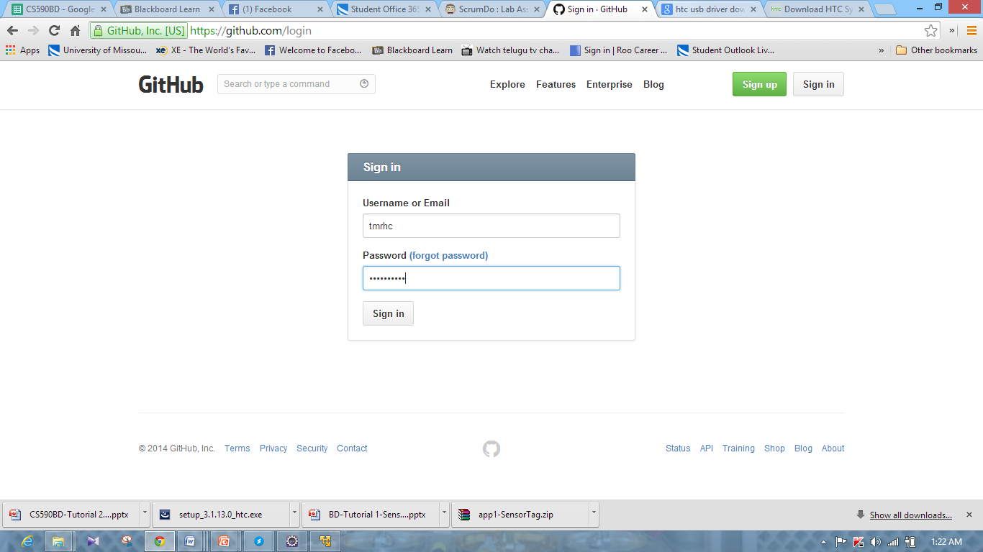

* Below screenshot represents the repository creation in Github.

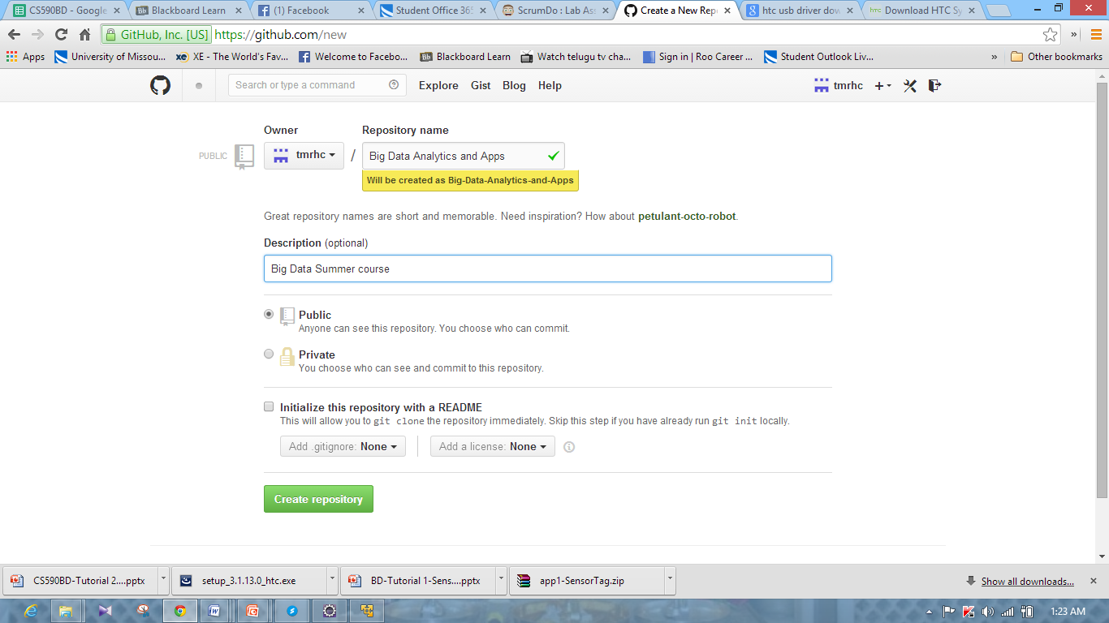

* Below screenshot represents the initialization of the repository in Github.

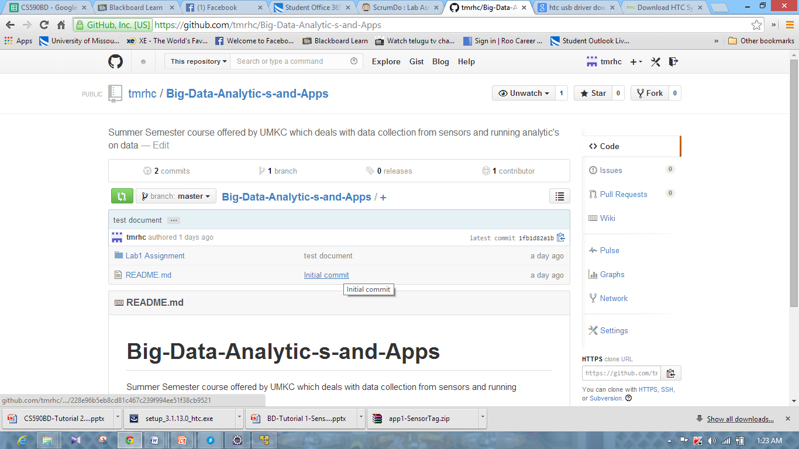

* Below screenshot represents the local Github.

